CSC 32200

Prof. Jie Wei

Pavlo Aleksyeyev and Jason Azayev

27 November 2019

Software Engineering Project Phase 2 Report

1. Introduction

*an overall picture of the system using collaboration class diagram*

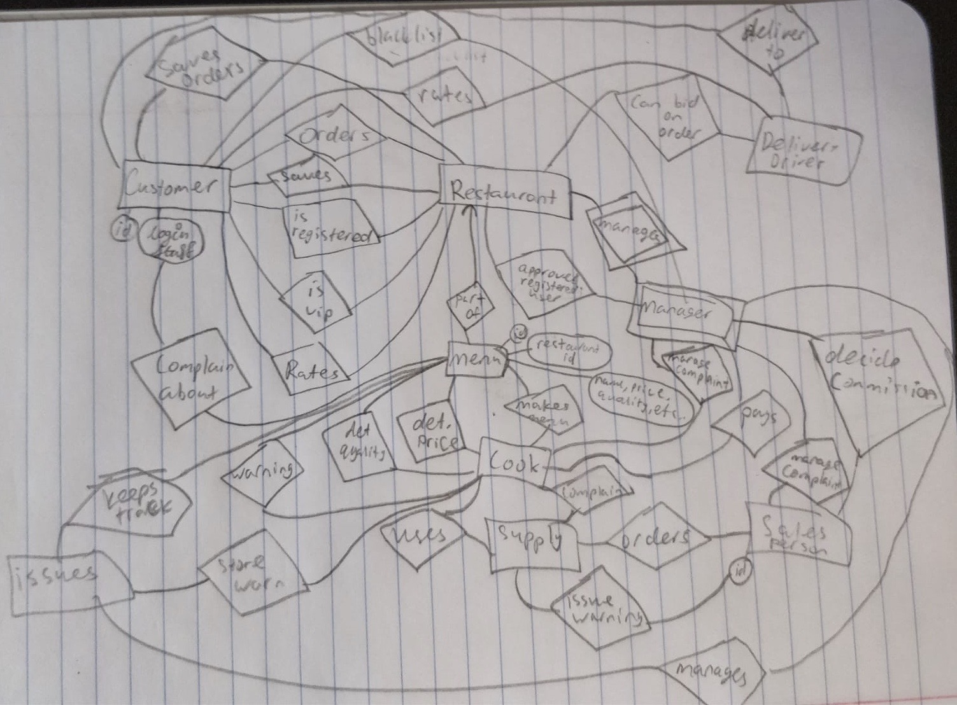

2. All use cases

o *Scenarios for each use case: normal AND exceptional scenarios*

*o Collaboration class diagram for each use case*

*o State diagram or Petri-net for each case*

**USE CASE REPORTS**

**Visitor Logging-In Use-Case Report**

* Participating actors: Customer- Visitor/ New User
* Flow of Events: The customer continues by opening our website. The customer reads the instructions stating: Existing users input username and password then click enter. New users input a username and password then click create account. Or click continue without filling out the username or password. The visitor does not input anything into the username or password and clicks on continue as visitor button.
* Entry Condition: The customer is logged on or is a visitor.
* Exit Condition: The customer is redirected to choose a restaurant.
* Quality Requirements: Upon clicking continue as visitor button, the next page should not take more than 5 seconds to change.

**Normal Scenario:** The Visiting Customer will not input a password or username, and proceed to click continue button for visitors. They will be redirected to the next page.

**Exceptional Scenario:** The customer does not input a password or username but proceeds to register. In this case we want there to be a message telling the user that they need to fill in a username and password or click on continue as visitor button.

**Visitor Registering Use-Case Report**

* Participating actors: Visitor the system and manager.
* Flow of Events: The visitor customer enters a username and password into the field and clicks sign up. Then a pop-up will appear where they will be able to enter their name, address, birthday, and other information. Once they are done filling out the entry fields then they must click register. When they click register then the manager will be notified. When the manager approves of their registration then they will be able to be a registered user.
* Entry Condition: Clicking on sign-up button
* Exit Condition: Manager approving them.
* Quality Requirements: Pop-up work, each button works, and the manager receives an approve request.

**Normal Scenario:** The user will input their username and password and click the register button. They will then be approved and confirmed.

**Exceptional Scenario:** The user inputs an existing username. This should not create an account and have the user prompted to create a more creative username.

**Registered and VIP Customers Logging-In Use-Case Report**

* Participating actors: Customer- (Regular Customer or VIP)
* Flow of Events: The customer continues by opening our website. The customer reads the instructions stating: Existing users input username and password then click enter. New users input a username and password then click create account. Or click continue without filling out the username or password. The returning customer inputs their username and password and clicks log-in button.
* Entry Condition: The customer is logged-in to their account.
* Exit Condition: The customer is redirected to the next page where they can choose a restaurant.
* Quality Requirements: Upon clicking continue the log-in button it should not take more than 5 seconds to change.

**Normal Scenario:** The registered and VIP customers will login by inputting their usernames and password. They will be successfully redirected to the restaurant page

**Exceptional Scenario:** They input an invalid username and password. We want to prompt the user stating that it is an invalid password and try to try again.

**All Types of Customers Choosing Restaurants Use-Case Report**

* Participating actors: A customer (all types) are redirected from log-in page to the choose restaurant page and restaurants
* Flow of Events: The customer inputs their location into the address field and clicks submit. The filter will show the customer all the possible restaurants near them in a given distance from them. The customer then clicks on a restaurant that they like.
* Entry Condition: The customer entered their address.
* Exit Condition: The Customer clicked on a restaurant of their choice.
* Quality Requirements: The click on a restaurant should redirect them to the restaurant’s menu page.
* **Normal Scenario:** The customer will see a selection of restaurant near their location (NYC only for now). The customer will then choose what restaurant they want and be redirected to the next page.
* **Exceptional Scenario:** The customer inputs a location that we do not yet cover. They will see a blank list of restaurants and be asked to try again.

**Customer Food Selection Use-Case Report**

* Participating actors: The customers and the menu items of a particular restaurant.
* Flow of Events: The customer sees all the available menu items. They choose the quantity and then click add to cart button. They continue until they are satisfied with their order.
* Entry Condition: The customer selects their food choices from entrees to desserts.
* Exit Condition: The customer clicks on checkout button.
* Quality Requirements: The quantity button should allow the customer to choose the desired quantity of an item. The add to order button should work. The checkout button redirect to check out page.
* **Normal Scenario:** The customer will click the add button for what ever food they want with the desired quantity and then click checkout. They will be redirected to the billing page and the manager will get their food order.
* **Exceptional Scenario:** The items chosen attempts to add zero quantity of an item. The system should not add zero quantity and just prompt the user to input a value greater than 0.

**Payment Process Use-Case Report **(JUST FOR SHOW-Payment Process Will Not Be Functional) \*\***

* Participating actors: Customer initiated with the checkout page
* Flow of Events: The customer enters the checkout page and sees all of their items. The customer can remove any of their items from the cart by clicking remove item button next to the menu item. At the bottom of the page there is a place order button. Once the customer is ready to move on they click the place order button and are redirected to the payment page.
* Entry Condition: The customer was redirected after clicking on the cart button.
* Exit Condition: The customer clicked on place order button and was redirected to the check-out page.
* Quality Requirements: All the buttons should work.
* **Normal Scenario:** The Check-out page is full of the customer’s items. The customer proceeds to then placing the order button. They will be redirected to the payment page.
* **Exceptional Scenario:** The customer gets rid of all of their items and still clicks payment page. In this case they should not be allowed to continue to payment page but rather get a warning message stating that the cart is empty.

**Manager Approve New Customer Use-Case Report**

* Participating actors: Manager and the System
* Flow of Events: The manager sees a customer is asking permission to become a registered customer. The manager then checks the blacklist to see if the customer is on the black list. If they are not, then they are approved.
* Entry Condition: The customer is notified that there is a registration request.
* Exit Condition: Manager clicks approve of denied button.
* Quality Requirements: That the buttons work and that the blacklist is functional.
* **Normal Scenario:** The manager will see a notification with a new customer registration. They will then proceed to approving them.
* **Exceptional Scenario:** The manager sees the notification and checks to see if the customer has been blacklisted or not. If they have been then the manager will not approve them.

**Blacklisted Customer Tries to Register Use-Case Report**

* Participating actors: Blacklisted customer, system and manager
* Flow of Events: A customer who has been blacklisted is attempting to re-register. The manager will be notified. The manager will see that the customer is on the black list and they will be denied.
* Entry Condition: blacklisted visitor tries to re-register.
* Exit Condition: The manager declines them.
* Quality Requirements: Black list must function.
* **Normal Scenario:** The blacklisted customer will still be able to attempt registration upon submission of their request to register.
* **Exceptional Scenario:** The manager will still approve the blacklisted customer by mistake. In this case the customer is just a regular customer again.

**Delivery Person Rating Use-Case Report**

* Participating actors: Delivery Person and the rating page.
* Flow of Events: The delivery person must click delivered, after the food has been handed off to the customer, on the page that they were redirected from after they won the bidding. The page just has one button asking to confirm if the delivery was complete. After that button is clicked then the delivery person will have a pop-up on their screen asking to rate the customer. If the rating is equal to or is less than 3 then they will be forced to leave a comment.
* Entry Condition: Clicking complete delivery.
* Exit Condition: Leaving rating
* Quality Requirements: Pop-up or new page must work.
* **Normal Scenario:** The customer sees the rating page and attempts to rate the delivery person. The attempt is successful upon selecting the rating and clicking submit.
* **Exceptional Scenario:** The delivery person did not select a rating and attempted to submit the rating anyways. The system should not allow the customer to move on to the next page but rather prompt them to choose a rating. Another exception case is when the delivery person has the rating system open but the customer has quickly submitted their review of the delivery person. In this case the delivery person will not be able to make a submission even though they are on the page.

**Customer Rating Delivery Use-Case Report**

* Participating actors: The customer will interact with the leave rating page.
* Flow of Events: The customer will receive their food. They will be able to leave a rating only after the delivery person clicks complete delivery. When the person clicks complete delivery the customer will be redirected from your food is on its way page to please rate your delivery person. They will be able to see a pop-up or a new page where they will rate the delivery person on a scale of one to five. If the rating is equal or below three, then they will have to leave a review. When they are finished rating and/or leaving the review they will be able to click submit rating.
* Entry Condition: Redirected to rating delivery person page after the delivery person clicks delivery completed.
* Exit Condition: The customer clicks on submit rating.
* Quality Requirements: The customer must be redirected to the rating page after the delivery person has completed the delivery and clicked on their button. Also, the rating must work for the customer.
* **Normal Scenario:** The customer liked the delivery person and gives a very good rating.
* **Exceptional Scenario:** The customer hates the food and gives a bad rating. The customer does not want to write a verbal review and proceeds to submission. They will not be allowed to submit the review without a written comment.

**Customer Rating the Food Use-Case Report**

* Participating actors: The customer will be interacting with the system viewing the rating food page.
* Flow of Events: The customer has clicked rate delivery person and is then asked to rate the food page. They will have the popup or new page waiting for them with fields for rating the food and a comment space to leave a comment if the food was less than 4 stars. They must click submit and then they will be redirected back to the original login page
* Entry Condition: Customer submits the delivery person rating
* Exit Condition: The customer submits the food rating.
* Quality Requirements: The customer must be redirected to their rate food page. The submission button must work.
* **Normal Scenario:** The customer will like the food and will leave a good rating. They will submit and they will be thanked for ordering and submitting.
* **Exceptional Scenario:** The customer attempts to submit the rating without actually rating. In this case they will be prompted to add a rating. The customer attempts to submit a bad rating without writing a comment. The customer will be prompted to submit the rating.

**Petri-Net Diagrams:**

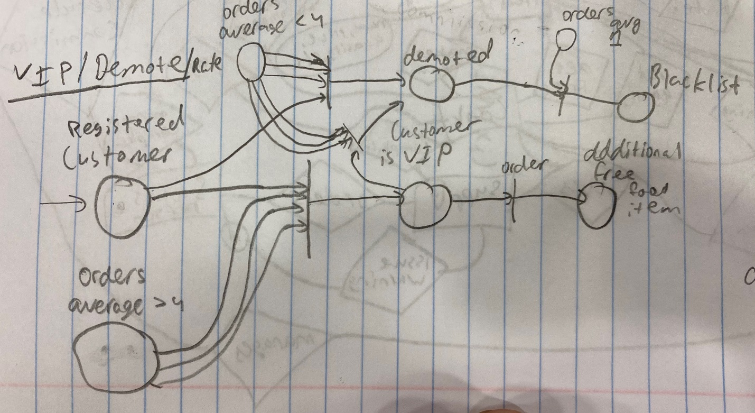

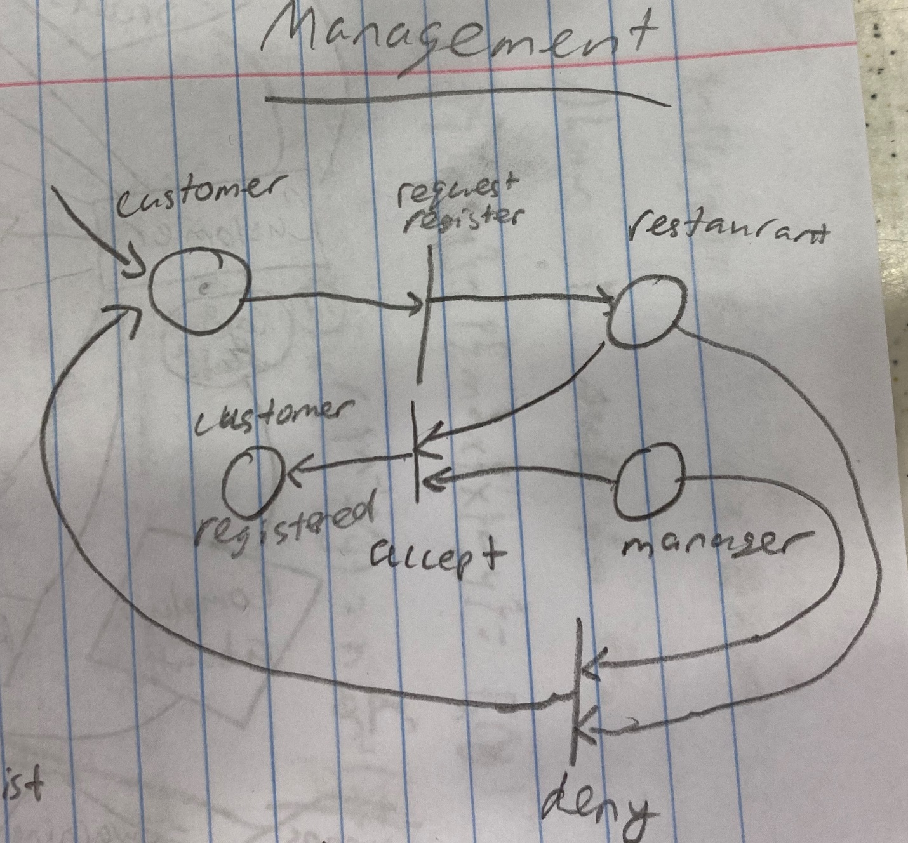

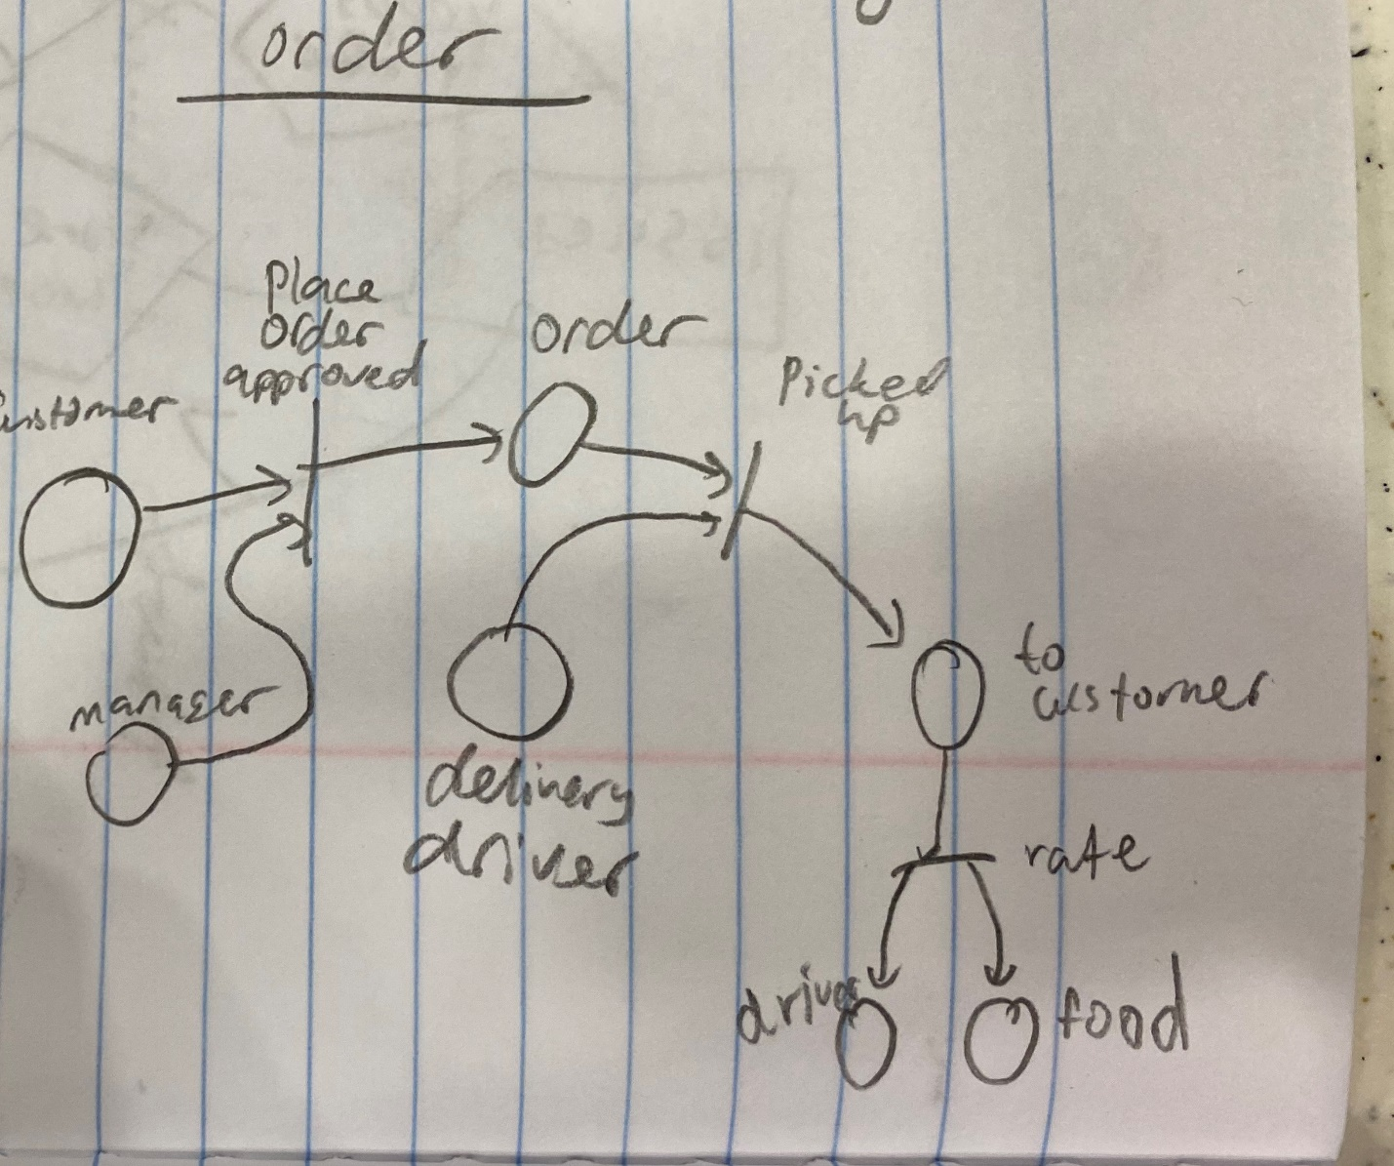

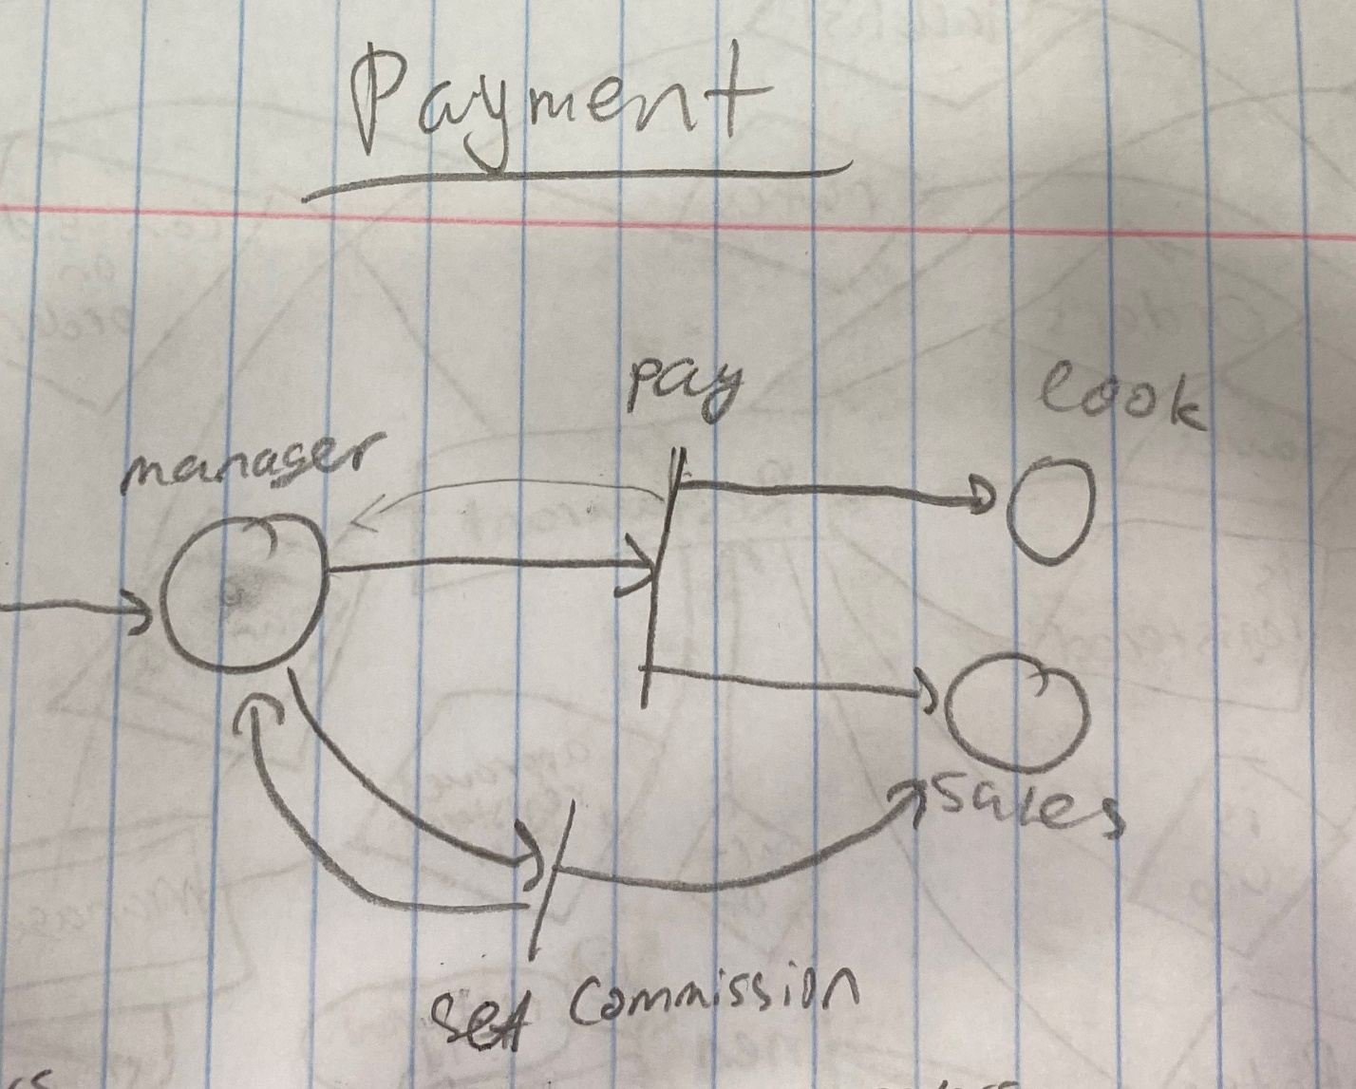

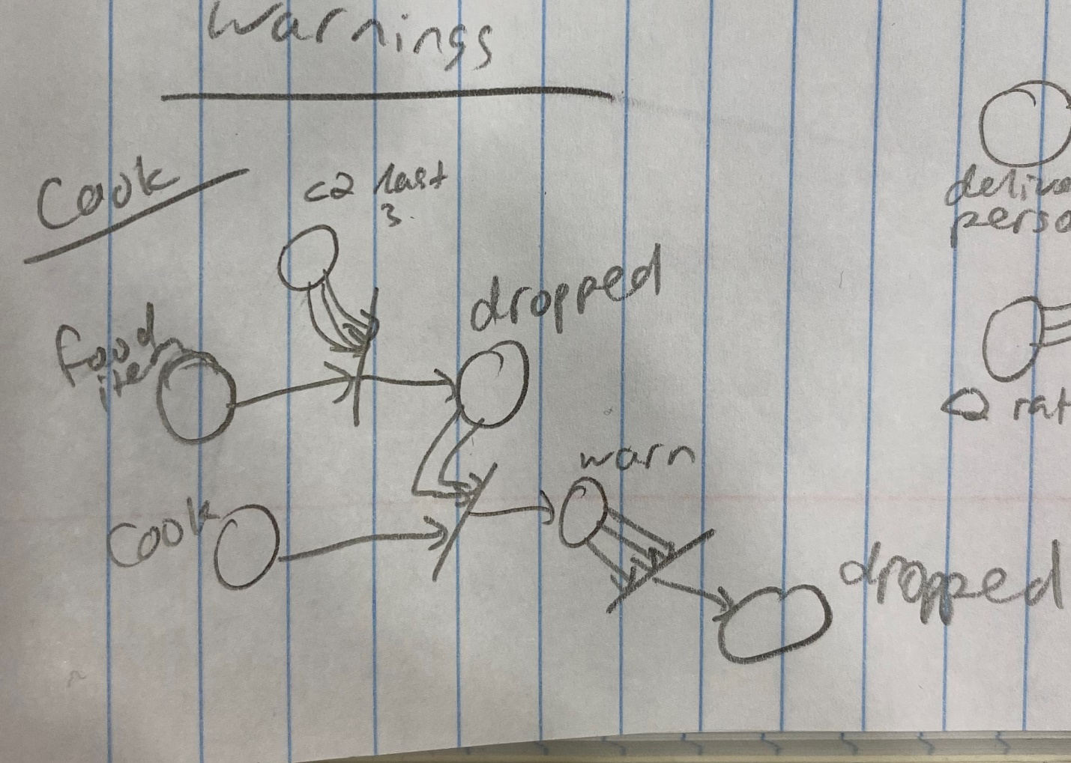

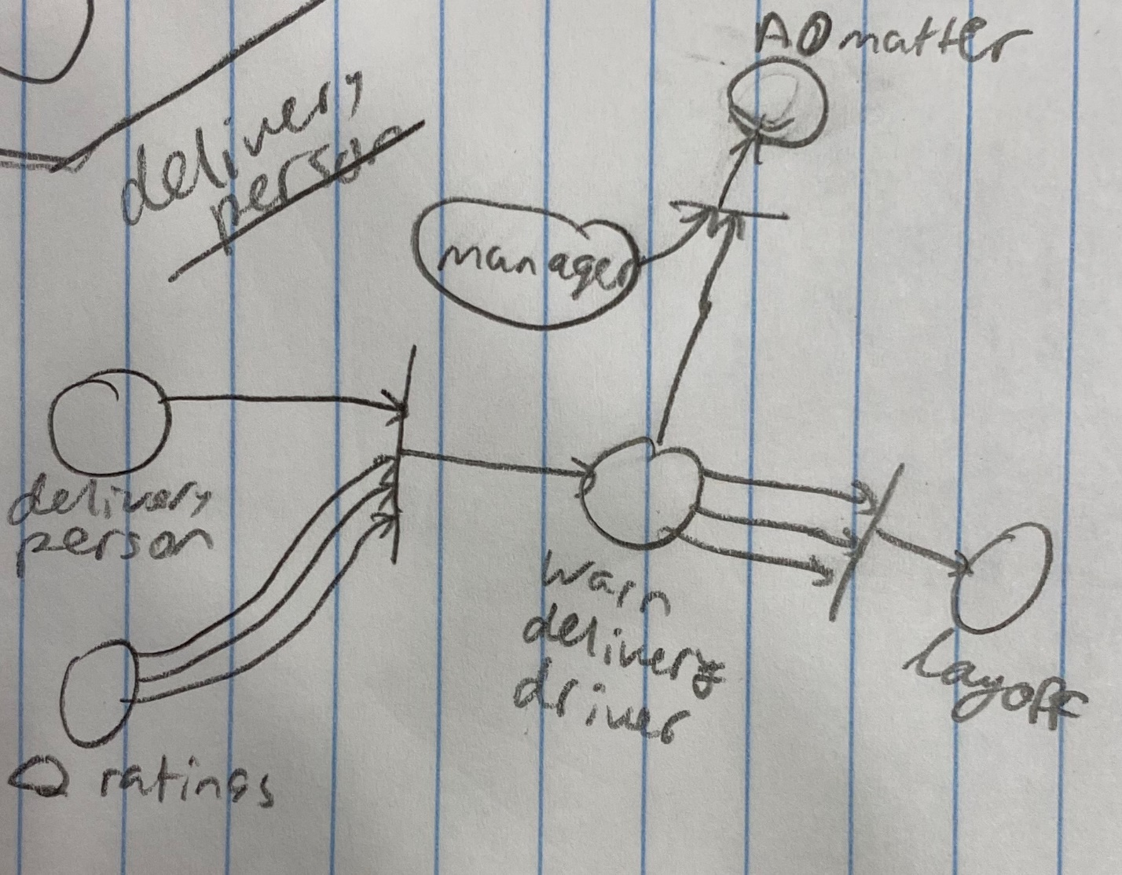

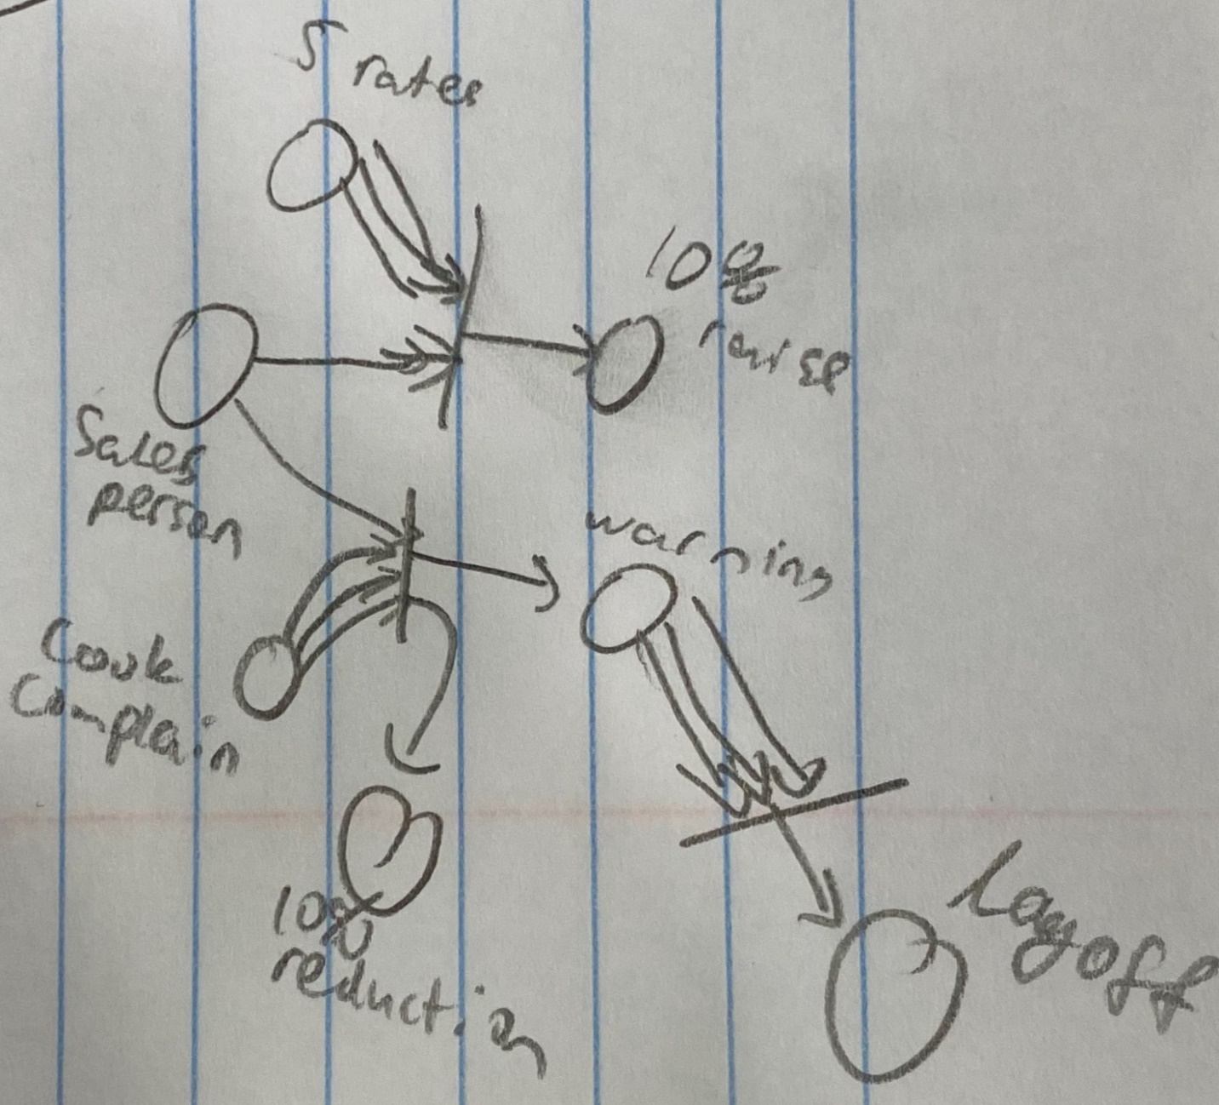

**Collaboration Diagrams:**

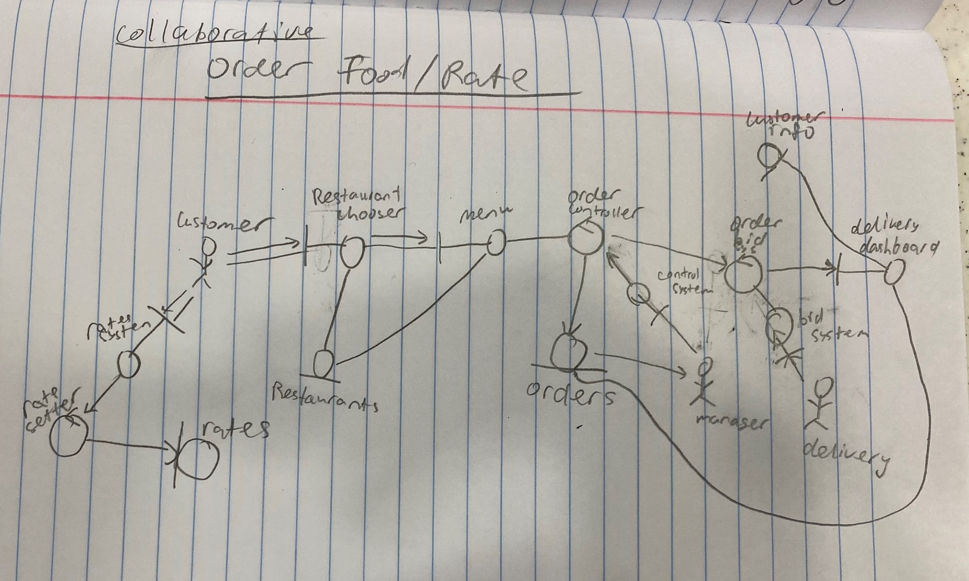

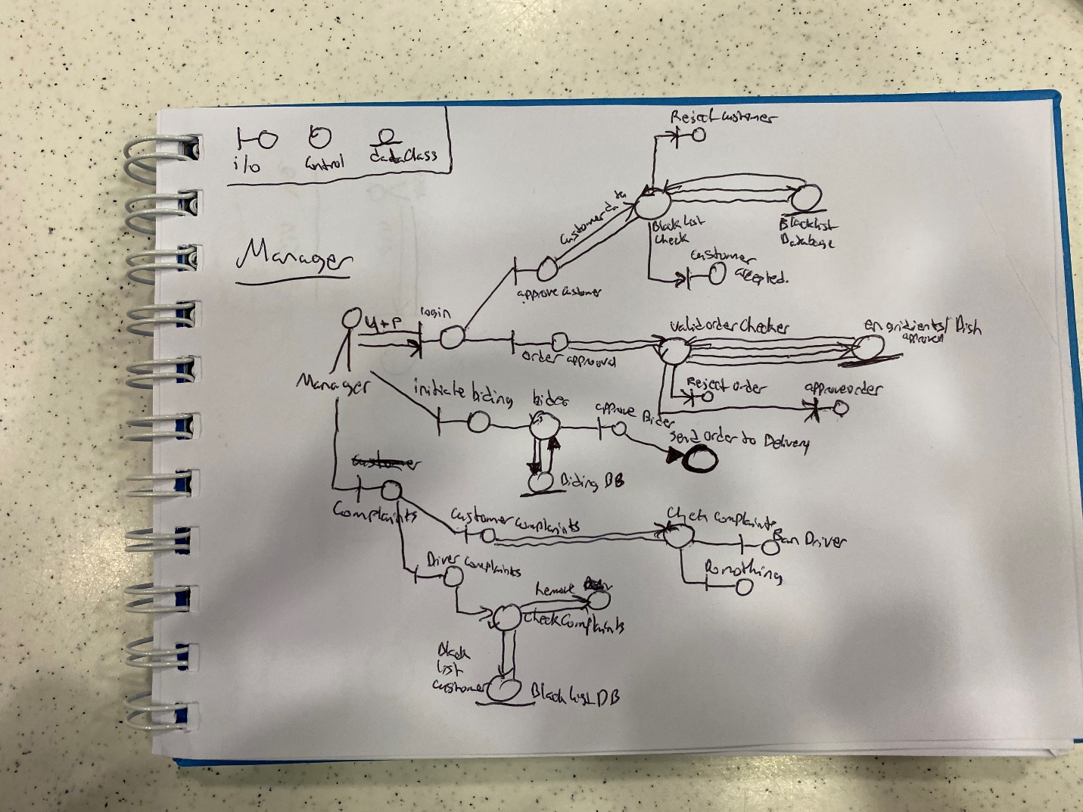

3. E-R diagrams for the entire system

*attributes and keys for each class should be provided*



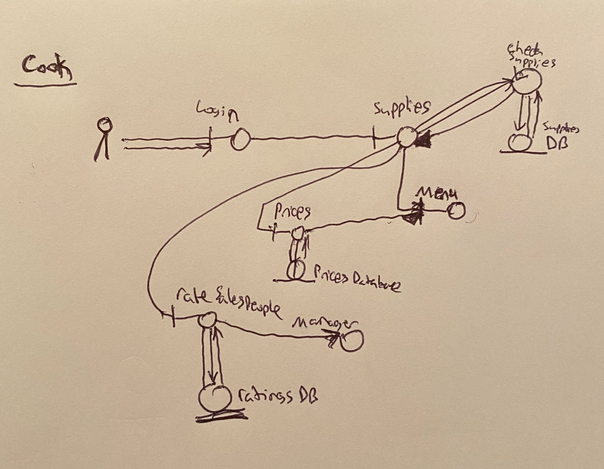

4. Detailed design

*for EVERY method use pseudo-code to delineate the input/output and*

*main functionalities*

For this project we are utilizing Python to build our general programing structures like classes and make connections to our Database and frontend/backend. Infused with python, we are using Flask to help make the project functional with our web pages. For the front end we are using HTML CSS and some Javascript. We do not have many visuals of our program running. We are using SQLAlchamy for the database. We will integrate our system to with all of these programs to bring us closer to success.

We are currently attempting to implement the log-in page for the users.

**Log-in:**

Base:

|  |  |
| --- | --- |
| <!DOCTYPE html> |  |
|  | <html> |
|  | <head> |
|  | {% if title %} |
|  | <title>{{title}}</title> |
|  | {% else %} |
|  | <title>Restaurant System</title> |
|  | {% endif %} |
|  | </head> |
|  | <body> |
|  | {%block content%} |
|  | {%endblock%} |
|  | </body> |
|  | </html> |

**Log-in:**

|  |  |
| --- | --- |
|  | **{%extends 'base.html'%}** |
|  | **{% block content %}** |
|  | **<h1>{{title}}</h1>** |
|  | **<form action="" method="POST">** |
|  | **{{ form.hidden_tag() }}** |
|  | **<p>** |
|  | **Username: {{form.username}} <br>** |
|  | **{% for error in form.username.errors %}** |
|  | **<span style="color: red;">[{{ error }}]</span>** |
|  | **{% endfor %}** |
|  |  |
|  | **Password: {{form.password}} <br>** |
|  | **{% for error in form.password.errors %}** |
|  | **<span style="color: red;">[{{ error }}]</span>** |
|  | **{% endfor %}** |
|  |  |
|  | **{{form.remember_me}}** |
|  | **</p>** |
|  |  |
|  | **<p> {{ form.submit() }} </p>** |
|  | **</form>** |
|  | **{% endblock content %}** |

**Register:**

|  |  |
| --- | --- |
|  | **{%extends 'base.html'%}** |
|  | **{% block content %}** |
|  | **<h1>{{title}}</h1>** |
|  | **<form action="" method="POST">** |
|  | **{{ form.hidden_tag() }}** |
|  | **<p>** |
|  | **Username: {{form.username}} <br>** |
|  | **{% for error in form.username.errors %}** |
|  | **<span style="color: red;">[{{ error }}]</span>** |
|  | **{% endfor %}** |
|  |  |
|  | **Email: {{form.email}}** |
|  | **{% for error in form.email.error%}** |
|  | **<span style="color: red;">[{{ error }}]</span>** |
|  | **{% endfor %}** |
|  |  |
|  | **Password: {{form.password}} <br>** |
|  | **{% for error in form.password.errors %}** |
|  | **<span style="color: red;">[{{ error }}]</span>** |
|  | **{% endfor %}** |
|  |  |
|  | **Confirm Password: {{form.password2}}** |
|  | **{% for error in form.password2.errors %}** |
|  | **<span style="color: red;">[{{ error }}]</span>** |
|  | **{% endfor %}** |
|  | **</p>** |
|  |  |
|  | **<p> <input type="submit" value="Sign in"></input> </p>** |
|  | **</form>** |
|  | **{% endblock content %}** |

**Database:**

|  |  |
| --- | --- |
|  | **from flask import Flask** |
|  | **from flask_sqlalchemy import SQLAlchemy** |
|  | **from flask_login import LoginManager** |
|  |  |
|  | **app = Flask(__name__)** |
|  | **app.config.from_object('config')** |
|  |  |
|  | **# Database** |
|  | **db = SQLAlchemy(app)** |
|  |  |
|  |  |
|  | **login_manager = LoginManager()** |
|  | **login_manager.init_app(app)** |
|  |  |
|  |  |
|  | **from app import views, models** |

**Forms:**

|  |  |
| --- | --- |
| **from flask_wtf import FlaskForm as Form** |  |
|  | **from wtforms import StringField, BooleanField, PasswordField, SubmitField** |
|  | **from wtforms.validators import DataRequired, Email, EqualTo, ValidationError** |
|  | **from app.models import User** |
|  |  |
|  | **class LoginForm(Form):** |
|  | **username = StringField('username', validators=[DataRequired()])** |
|  | **password = PasswordField('password',validators=[DataRequired()])** |
|  | **remember_me = BooleanField('remember', default=False)** |
|  |  |
|  | **submit = SubmitField('Login')** |
|  |  |
|  | **class RegisterForm(Form):** |
|  | **username = StringField('Username', validators=[DataRequired()])** |
|  | **email = StringField('Email', validators=[DataRequired(), Email()])** |
|  | **password = PasswordField('Password', validators=[DataRequired()])** |
|  | **password2 = PasswordField(** |
|  | **'Repeat Password', validators=[DataRequired(), EqualTo('password')])** |
|  | **submit = SubmitField('Register')** |
|  |  |
|  | **def validate_username(self, username):** |
|  | **user = User.query.filter_by(username=username.data).first()** |
|  | **if user is not None:** |
|  | **raise ValidationError('Please use a different username.')** |
|  |  |
|  | **def validate_email(self, email):** |
|  | **user = User.query.filter_by(email=email.data).first()** |
|  | **if user is not None:** |
|  | **raise ValidationError('Please use a different email address.')** |

**Models:**

|  |  |
| --- | --- |
|  |  |
| **from app import db** |  |
|  | **import flask_login** |
|  | **from werkzeug.security import generate_password_hash, check_password_hash** |
|  |  |
|  | **class User(db.Model, flask_login.UserMixin ):** |
|  | **"""** |
|  | **The main user model for our software. This should include the user type and all** |
|  | **its attributes.** |
|  |  |
|  | **"""** |
|  | **__tablename__ = 'user'** |
|  |  |
|  | **id = db.Column(db.Integer, autoincrement=True, primary_key=True)** |
|  | **username = db.Column(db.String(100), index=True, unique=True)** |
|  | **email = db.Column(db.String(100), index=True, unique=True)** |
|  | **password_hash = db.Column(db.String(255))** |
|  |  |
|  | **authenticated = db.Column(db.Boolean, default=False)** |
|  |  |
|  | **def set_password(self, password):** |
|  | **self.password_hash = generate_password_hash(password)** |
|  |  |
|  | **def check_password(self, password):** |
|  | **return check_password_hash(self.password_hash, password)** |
|  |  |
|  | **def is_active(self):** |
|  | **"""True, as all users are active."""** |
|  | **return True** |
|  |  |
|  | **def get_id(self):** |
|  | **"""Return the email address to satisfy Flask-Login's requirements."""** |
|  | **return self.id** |
|  |  |
|  | **def is_authenticated(self):** |
|  | **"""Return True if the user is authenticated."""** |
|  | **return self.authenticated** |
|  |  |
|  | **def is_anonymous(self):** |
|  | **"""False, as anonymous users aren't supported."""** |
|  | **return False** |
|  |  |

**Views:**

|  |  |
| --- | --- |
| **from app import app** |  |
|  | **from flask import render_template, request, redirect, url_for, flash** |
|  | **from app.forms import LoginForm, RegisterForm** |
|  | **import flask_login as fl** |
|  | **from flask_login import current_user, login_user, logout_user** |
|  |  |
|  | **from app.models import User** |
|  | **from app.models import db** |
|  |  |
|  | **login_manager = fl.LoginManager()** |
|  |  |
|  | **@login_manager.user_loader** |
|  | **def user_loader(id):** |
|  | **return User.query.filter_by(id=id).first()** |
|  |  |
|  | **login_manager.login_view = "login"** |
|  |  |
|  | **login_manager.init_app(app)** |
|  |  |
|  |  |
|  |  |
|  | **@app.route('/logout')** |
|  | **def logout():** |
|  | **logout_user()** |
|  | **return redirect(url_for('index'))** |
|  |  |
|  |  |
|  | **@app.route('/')** |
|  | **def index():** |
|  | **if current_user.is_authenticated:** |
|  | **return "Welcome {}".format(current_user.username)** |
|  | **return "Works!"** |
|  |  |
|  |  |
|  | **@app.route('/register', methods=['GET', 'POST'])** |
|  | **def register():** |
|  | **if current_user.is_authenticated:** |
|  | **return redirect(url_for('index'))** |
|  | **form = RegisterForm()** |
|  | **if form.validate_on_submit():** |
|  | **user = User(username=form.username.data, email=form.email.data)** |
|  | **user.set_password(form.password.data)** |
|  | **db.session.add(user)** |
|  | **db.session.commit()** |
|  | **# flash('Congratulations, you are now a registered user!')** |
|  | **return redirect(url_for('login'))** |
|  |  |
|  | **return render_template('register.html', title='Register', form=form)** |
|  |  |
|  | **@app.route('/login', methods=['GET','POST'])** |
|  | **def login():** |
|  | **if current_user.is_authenticated:** |
|  | **return redirect(url_for('index'))** |
|  |  |
|  | **form = LoginForm()** |
|  |  |
|  | **if form.validate_on_submit():** |
|  | **user = User.query.filter_by(username = form.username.data).first()** |
|  | **if user is None or not user.check_password(form.password.data):** |
|  | **# flash('Invalid username or password')** |
|  | **return redirect(url_for('login'))** |
|  | **login_user(user, remember=form.remember_me.data)** |
|  | **return redirect(url_for('index'))** |
|  |  |
|  | **return render_template('login.html', title="Sign In", form=form)** |

## Current Plan for Next Steps (subject to change)

Technologies:

* Python3 Flask (Gunicorn for more than 1 user support)
* Amazon Buckets (if time permits for images)
* SQLAlchema (Database manager for MySQL DB)
* More to be added

Schema: To be added. Aim: Minimum (Hopefully 0) deletions. Tables done to support such.

*Possible Addition*: Suppliers, Supplier_Item are another type in our system, which communicate with sales people. "Communicate" meaning placing orders.

5. System screens

*demonstrate major GUI screens of the system and a prototype of one*

*functionality of your own choice.*

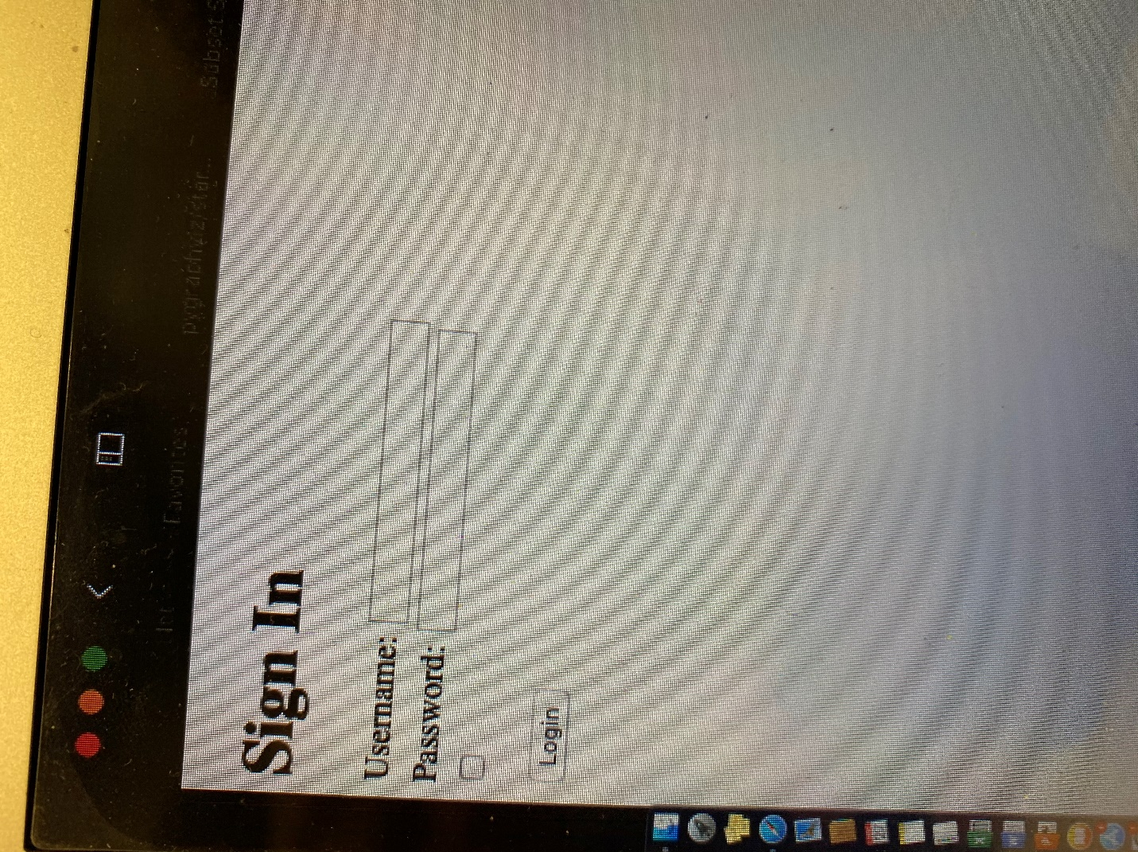

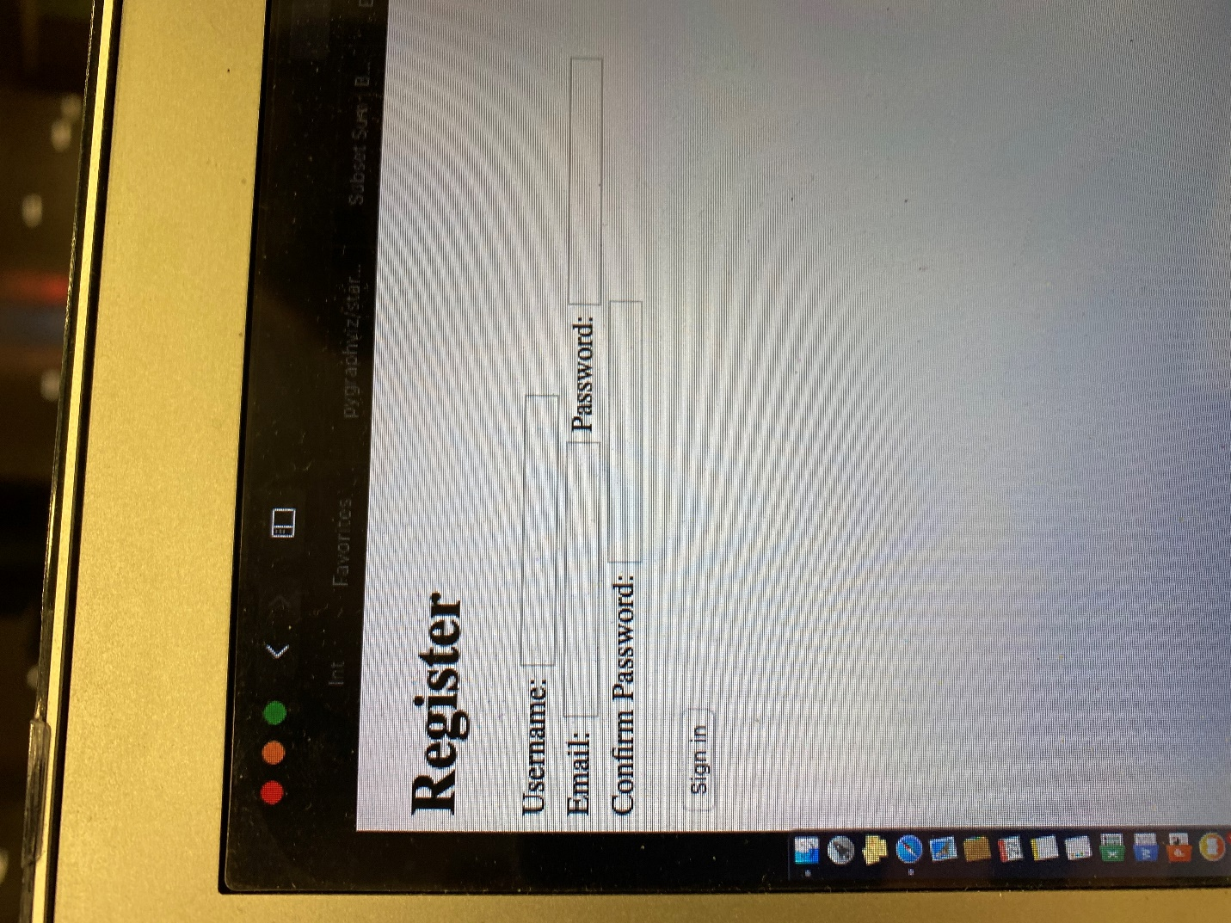

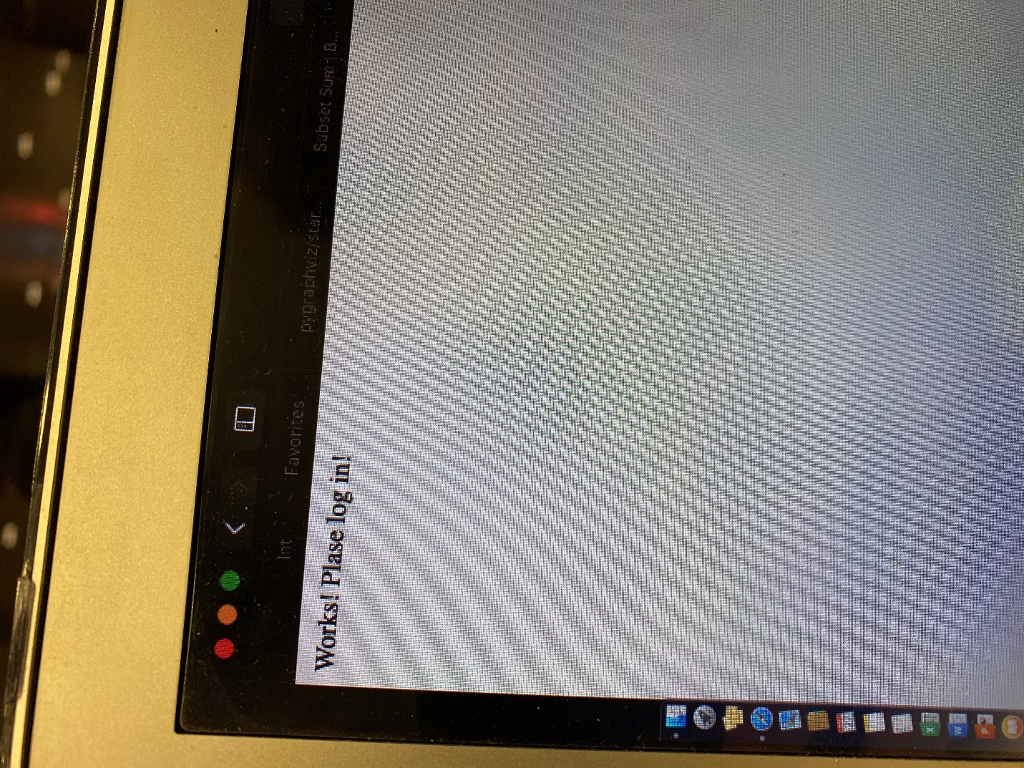

6. Minutes of group meetings and possible concerns of team work

Jason and I are a good team. He is good at backend and I am good at frontend. I will be building the frontend after the end of Thanksgiving. One issue that we are having is that the scale of the project is huge. We are only a team of two since our old teammate dropped the class. We will do our best to implement the main features of the program. Going forward we are striving to make the code work and match the requirements. We both hope that the size of our team will be taken into account when we are being graded.

7. Address of the git repo (github, gitlab, bitbucket, etc) of your

team's work so far - *put all materials including this report there*

<https://github.com/PredatorFeesh/RestaurantSystem-csc322>